**VPC USING CLOUD FORMATION**

* AWS Cloud Formation is an Amazon Web Services (AWS) service that allows users to build, set up, and manage resources in their cloud infrastructure through code.
* With Cloud Formation, you can create and provision AWS infrastructure resources using templates, and text files written in JSON or YAML format.
* The template must be declarative and versioned.

**STEPS TO BUILD VPC USING CLOUD FORMATION TEMPLATE:**

**STEP 1:** Create Stack.

**Stack**: A stack is a collection of AWS resources that you can manage as a single unit. If you delete a stack, all the resources within it are also deleted, which helps with easy teardown and clean up.

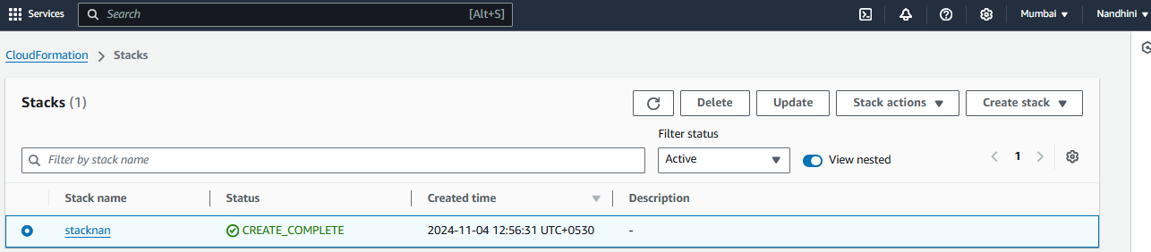

**STEP 2:** Write a Template to build VPC, public and private subnet, IGW which to be attached in VPC.

***YAML CODE:-***

*Resources:*

*VPCCF:*

*Type: AWS::EC2::VPC*

*Properties:*

*CidrBlock: '10.0.0.0/24'*

*EnableDnsSupport: true*

*EnableDnsHostnames: true*

*Tags:*

*- Key: Name*

*Value: VPCCF*

*PubSNCF:*

*Type: AWS::EC2::Subnet*

*Properties:*

*VpcId: !Ref VPCCF*

*CidrBlock: '10.0.0.0/28'*

*MapPublicIpOnLaunch: true*

*AvailabilityZone: !Select [0, !GetAZs '']*

*Tags:*

*- Key: Name*

*Value: PubSNCF*

*PriSNCF:*

*Type: 'AWS::EC2::Subnet'*

*Properties:*

*VpcId: !Ref VPCCF*

*CidrBlock: '10.0.0.16/28'*

*MapPublicIpOnLaunch: false*

*AvailabilityZone: !Select [1, !GetAZs '']*

*Tags:*

*- Key: Name*

*Value: PriSNCF*

*IGWCF:*

*Type: AWS::EC2::InternetGateway*

*Properties:*

*Tags:*

*- Key: Name*

*Value: IGWCF*

*AttachGateway:*

*Type: 'AWS::EC2::VPCGatewayAttachment'*

*Properties:*

*VpcId: !Ref VPCCF*

*InternetGatewayId: !Ref IGWCF*

*Outputs:*

*VPCId:*

*Description: VPC ID*

*Value: !Ref VPCCF*

*PublicSubnetId:*

*Description: Public Subnet ID*

*Value: !Ref PubSNCF*

*PrivateSubnetId:*

*Description: Private Subnet ID*

*Value: !Ref PriSNCF*

*InternetGatewayId:*

*Description: InternetGateway ID*

*Value: !Ref IGWCF*

**STEP 3:** Valid template and check for the events.

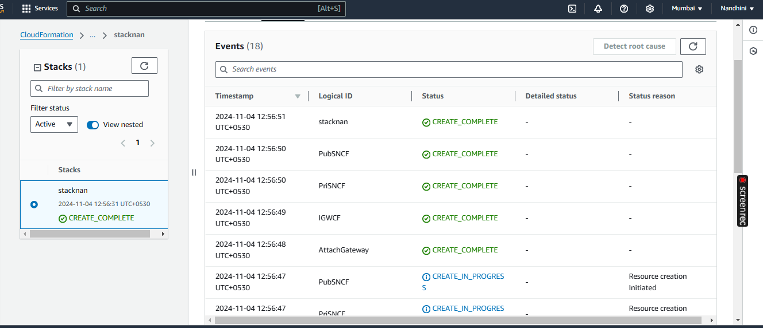

**OUTPUT:**

VPC Created using CFT:

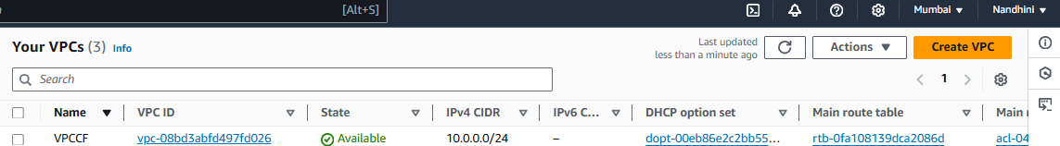

Public and Private subnets created using CFT:

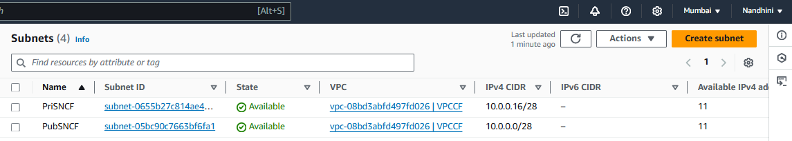

Internet Gateway:

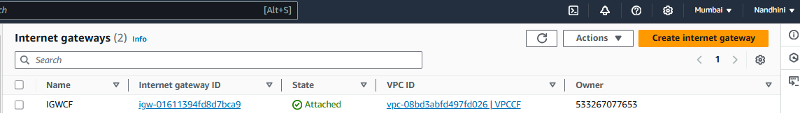

IGW attached to VPC created using CFT:

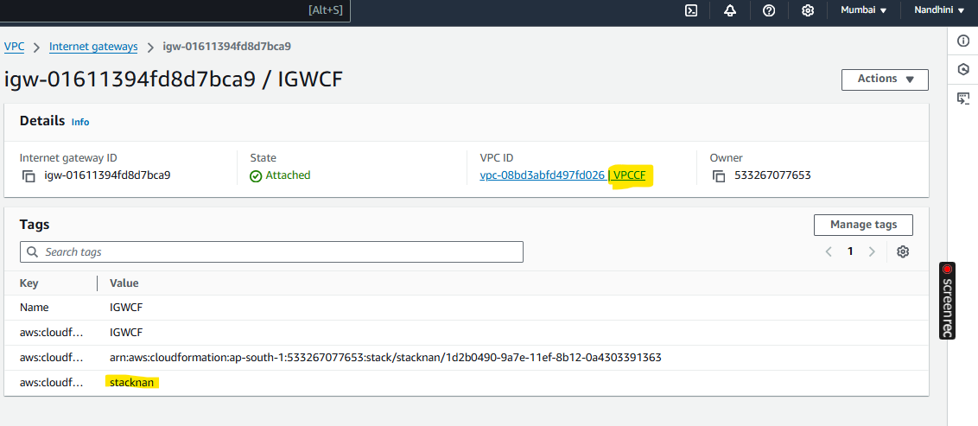

**DRIFT DETECTION:**

**Drift detection** is a feature that checks if the actual state of resources in a CloudFormation stack differs from the expected state defined in the stack’s template. With drift detection, you can identify, view, and respond to these changes, ensuring your infrastructure stays consistent and compliant with the original template.

Manually deleted Private Subnet and checked using Detect stack drift as below,

